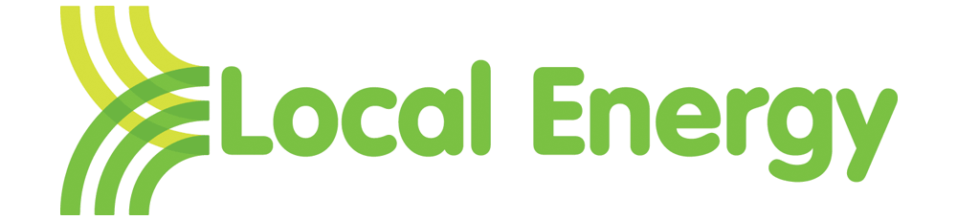
Local Energy Customer Complaints Form
If you have a complaint about any aspect of our service, then we would like to hear from you. You can contact us by telephone or by secure email.

It is usually best to contact us by phone to discuss your complaint, as our Customer Services staff will do their best to work with you to resolve it. Please call customer services on 02075542800 (9am to 5pm Monday to Friday. Out of hours please call 07753724495.

Alternatively, please complete the following form. Our initial response will usually be to your email address. However, there may be occasions when we will need to respond by post - to ensure privacy or to enclose copies of other documents.

Date: / /
Name:

Address:

Postcode:

Daytime telephone number:

Email address:

Green deal plan number

Description of complaint:

Contact with us so far:

What actions would you like us to take?:

For office use only
Complaint recipient
Complaint number
Complaint type
Responsible manager
Ombudsman ref if necessary
Resolution date

